**Concept:**

* Enclosed area with pond in the centre (water = tranquil, water sounds)
* Surrounded by trees and hills – greenery and natural plants = tranquil
* Pathway going through the area(?) – where the player has come from
* Large tree next to the pond – centre of focus – pink leaves (pink ‘promotes tranquillity and peace’, soothes energy)
* Blues and greens are peaceful colours but muted shades of other colours are also found to be soothing
* Around the edge of the pond, ‘glowing’/luminous flowers – wonder & curiosity
* Sounds – water, bird song, gentle breeze, leaves blowing

Moodboards:

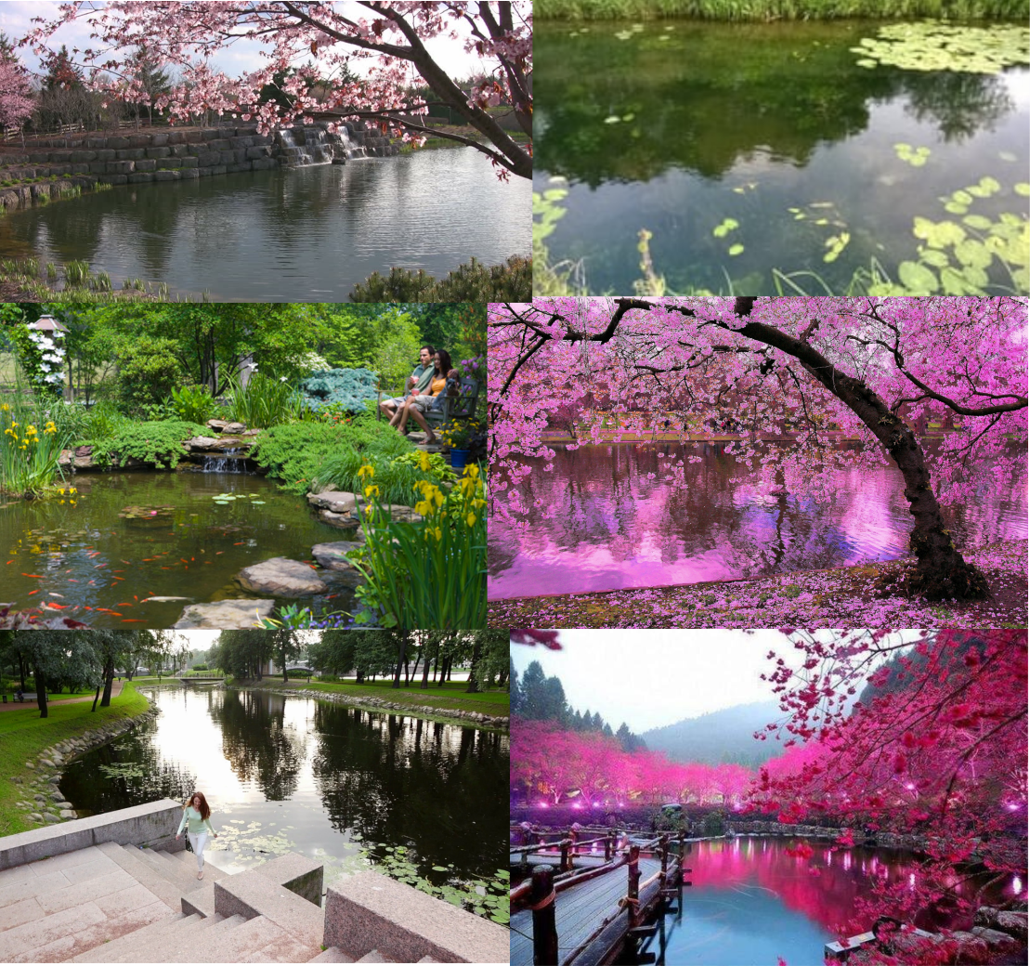

Enclosed, quiet area with a pond in the middle.

Trees and plants surrounding the area

Leaves from the large tree on the ground in and around the water

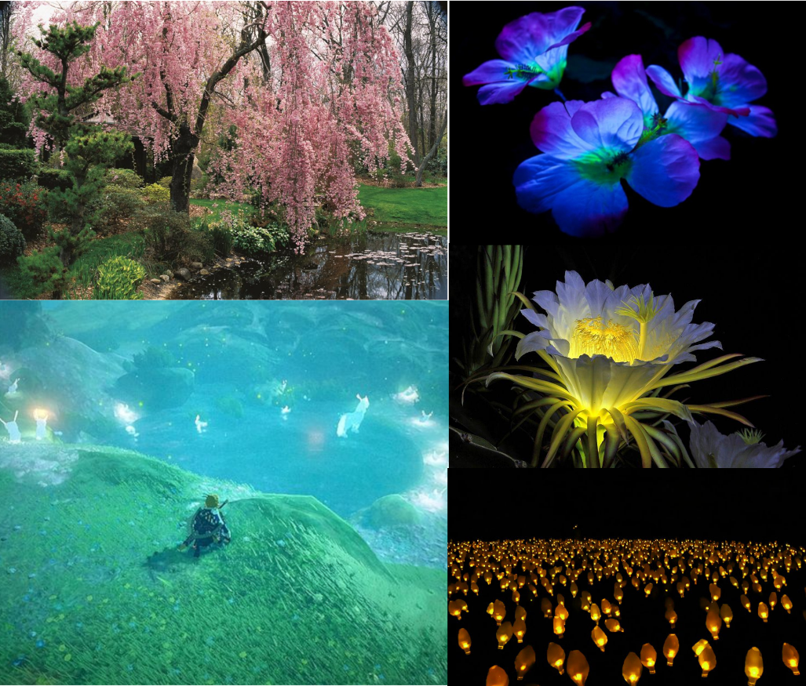

Large tree over the pond

Subtle glowing flowers

Glowing flowers dotted around the edge of the pond

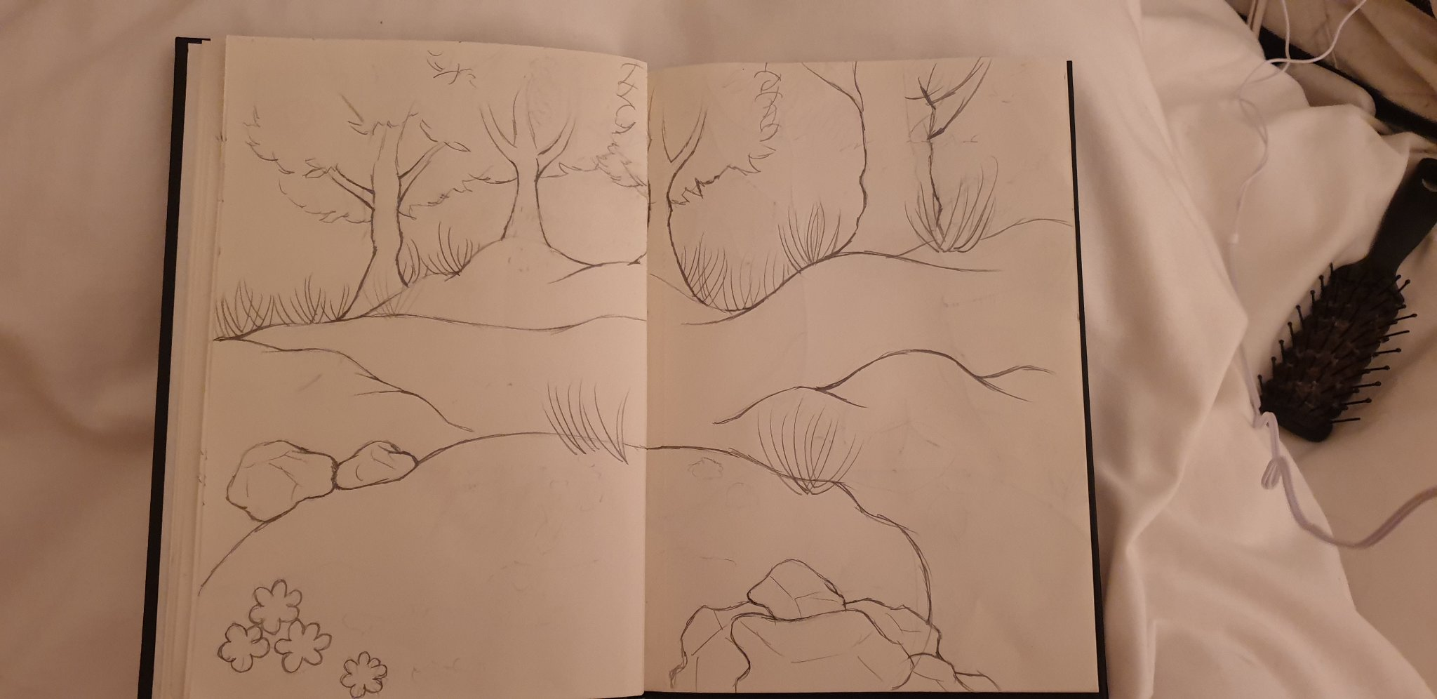Drawings:

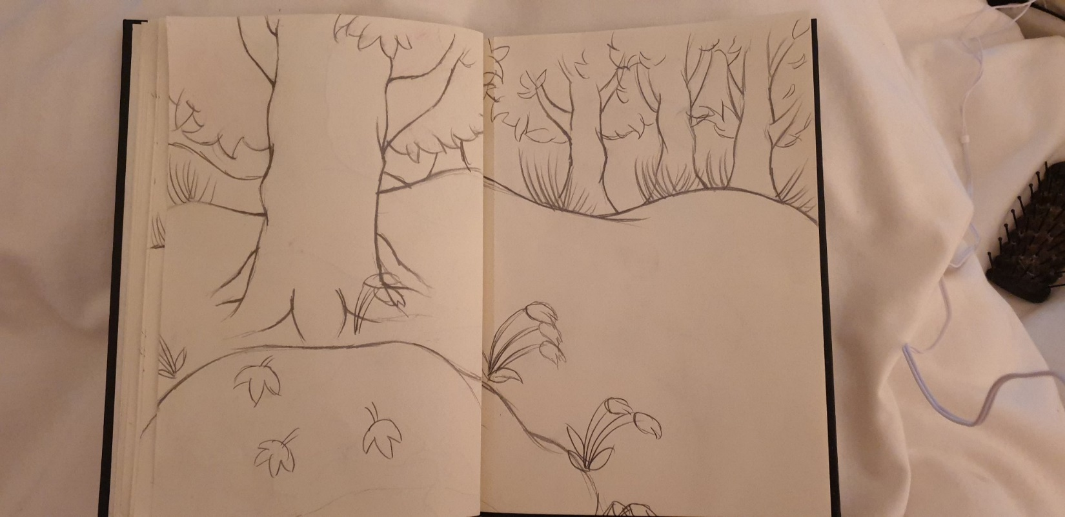

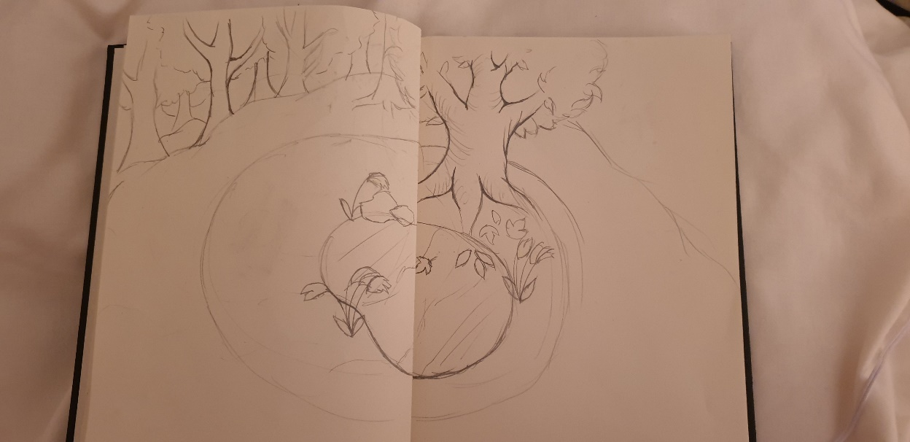

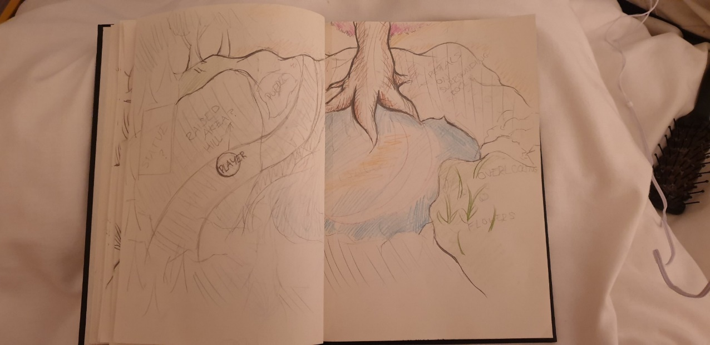

Unity Skyboxes:

<https://assetstore.unity.com/packages/2d/textures-materials/sky/free-hdr-sky-61217>

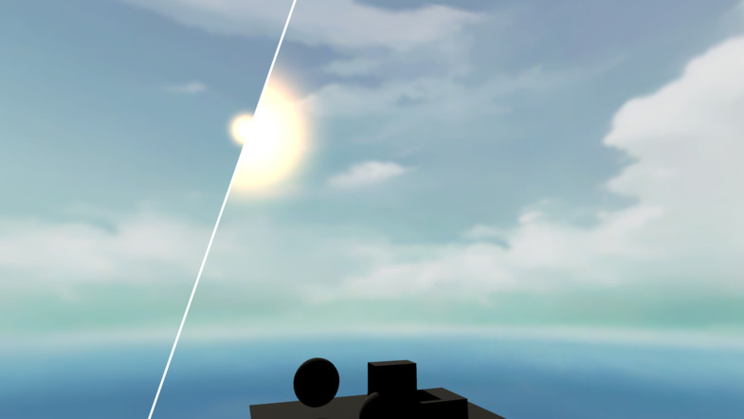

<https://assetstore.unity.com/packages/vfx/shaders/dynamic-sky-shader-125881>

<https://assetstore.unity.com/packages/vfx/shaders/free-skybox-cubemap-extended-107400>

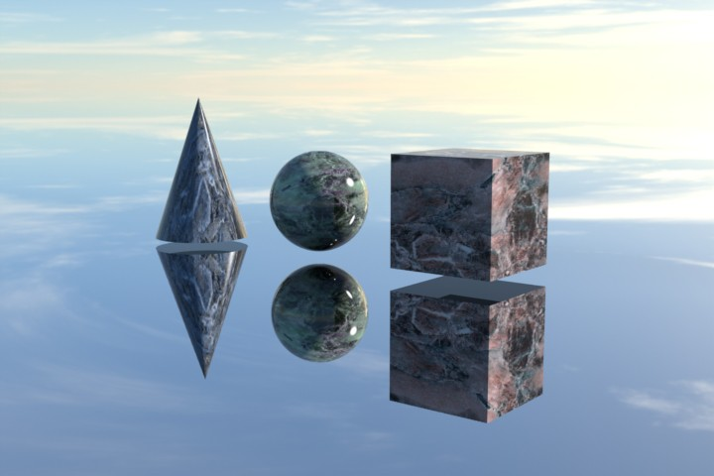<https://assetstore.unity.com/packages/2d/textures-materials/sky/worldskies-free-86517>

<https://assetstore.unity.com/packages/2d/textures-materials/sky/wispy-skybox-21737>



<https://assetstore.unity.com/packages/2d/textures-materials/sky/colorskies-91541>



<https://assetstore.unity.com/packages/2d/textures-materials/sky/10-skyboxes-pack-day-night-32236>

<https://assetstore.unity.com/packages/2d/textures-materials/sky/skybox-4183>

<https://assetstore.unity.com/packages/2d/textures-materials/sky/skysphere-volume-1-4042>

<https://assetstore.unity.com/packages/2d/textures-materials/sky/classic-skybox-24923>